PROJECT PROPOSAL

NIHVA TECHNOLOGIES PVT. LTD.
187, G-Block, Thermax chowk, Above Renault Showroom, MIDC
Chinchwad, Pune – 411019.

Customer Name | IKEA
Project Name | Hydraulic Bailing Press
Project Location | Pune
Contact Person Name | Mr. Rahul Borate
Email Id | rahul.borate@ikea.com
Contact Number | 7020097007

Contact Person: Ms. Varsha Date: 30.08.2019
Mob No.: 8551091333 SQT.19.20.2004
Email id: support@nihva.com
Web: http://www.nihva.com

NIHVA – Hydraulic Non – Metallic Scrap Bailing Press

Purpose of Hydraulic Baling Machine: –

Industries are facing a lot of problems in storing and handling the scrap. A large amount of space is required to store the scrap. In order to overcome these problems, the scraps can be compressed and stored in a brick form. Today, all the modern manufacturing enterprises are trying to develop best optimized reduced weight and cost-effective products that meet the intended design functionally and reliably. In this scenario, structural optimization tools like topology and shape optimization with manufacturing simulations are becoming attractive in product design processes. These tools also aid in reducing product development times. In last few years, shape optimization has emerged as the valuable tool to develop new design proposals especially in paper industries.

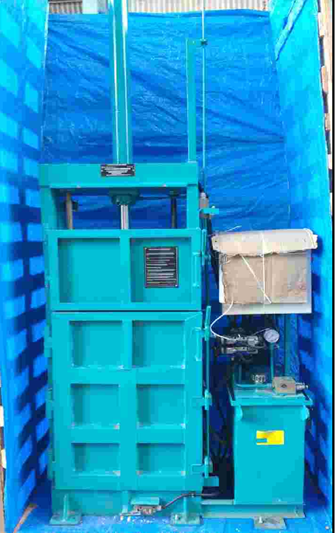

INTRODUCTION: -

A Baling machine is a device used to compress materials into a bale for storage, transport, or handling. Several types of machines exist for this purpose, as some are designed specifically for one material, while others may be able to handle various materials. Hydraulic scrap baling presses are machinery that find usage to compress different types of scraps into bale forms using hydraulic power. These presses are used in different ways to compress light, thin as well as soft materials. With several kinds of balers available for different materials/applications, these Balers are also used in material recycling facilities. There is also a provision of tying bales manually with help of provided grooves, thus helping in saving much cost of transportation. Hydraulic scrap bailing presses are designed for:

- Paper scrap
- Plastic scrap
- Cotton waste

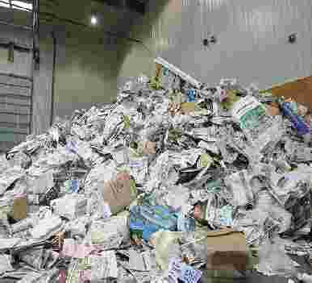
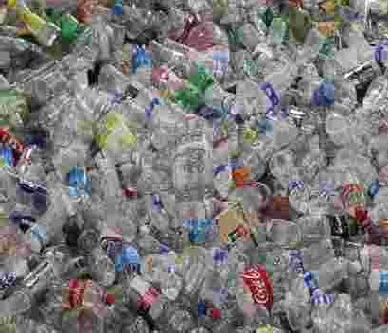
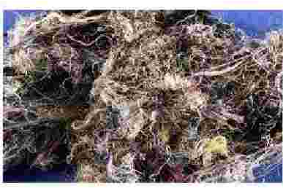

Paper
Pet Bottle
Cotton

All these can be formed into cuboid bales. Further, as the density of bales is high, these are also convenient to store, transport and used in metallurgy. Featuring complex electrical-hydraulic control have two working modes viz.

Auto & Inching, these come with pressure adjustable facility that make these Hydraulic scrap baling presses best in performance as well as easy in working and high in productivity. Since high degree of compaction is achieved, it helps in saving expensive storage space as well as allows making transport and handling easier. These balers are made of steel with hydraulic Ram for compressing the material loaded. Some balers offered are simple and labor-intensive, but suitable for smaller volumes.

We Have A Solution: -

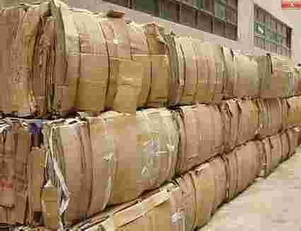
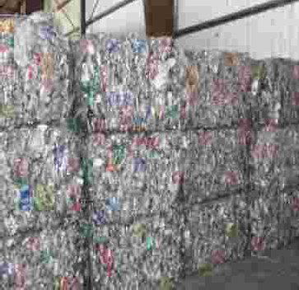
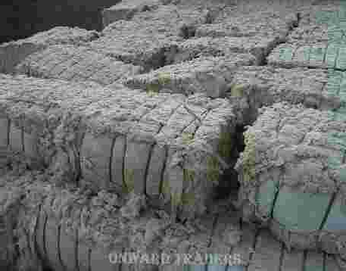

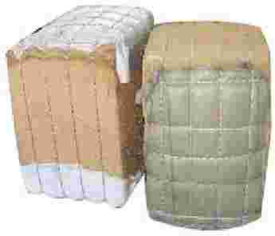
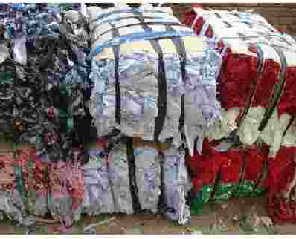


CONCLUSIONS: -

- The bales formed by this machine helps in easy handling, storage and transportation.

- The maneuverability of the device is quite good and the handling is quite simple.

- Optimization design is compared to the actual part design that is being manufactured for the scrap baling press and hydraulic press.

- It is inferred that under the same loading conditions, constraints and intended design purposes, shape optimization results in better and more reliable design.

Hydraulic Vertical Non – Metallic Scrap Bailing Press: -

- Limit switch inter lock
- To eliminate accidents, mishandling of machine
- Interlocks to both doors
- Main door and feeding door of both sides Inter locks to the bottom tilting plate provided.
- Interlocks to moving (pressing) plate at return stroke

Dos and don’ts: -

Here are some basic dos and don’ts regarding baler operation and maintenance.
- Do keep your baler clean and inspect it often. Don’t neglect completing inspections. Your baler operator(s) and/or maintenance personnel should be, at a minimum, following the guidelines spelled out by the equipment manufacturer as it relates to daily, weekly, monthly and annual inspections and preventive maintenance. Balers get hot, and dust is an insulator, so keep it clean and take precautions to ensure the cooler and the motors are cleaned daily

- Do purchase and maintain an inventory of spare parts. Don’t wait until the last minute to order critical spares that might keep your plant down longer than you would like. Downtime is a subject worthy of its own story, but the bottom line is the only people making money when your plant is down are your vendors and potentially your competition. Don’t get caught with your baler down because you don’t want to invest the extra money into spare parts inventory. Ask your baler representative what recommended critical spare parts you should have on hand and what the lead times are on the larger items.

- Do plan preventive and anticipated major maintenance. Don’t wait until the baler breaks to make necessary repairs that can be prevented by performing routine maintenance. Based on volumes of materials processed, your baler is going to need major work done at some point, such as being relined. This can take from three to seven days depending on baler type, size and the condition of the machine at time of reline. This is not an “if” scenario but a “when” scenario and not planning for it will only cost you more money.
Preventive maintenance on your baler does more than keep your baler operating properly, it also helps to ensure safe operation. A typical preventive maintenance program should include daily, weekly and monthly inspections of various components. Each inspection, regardless of the schedule, should start with safety in mind.
In addition to safety and helping to avoid serious break downs, routine preventive maintenance will help to increase the life expectancy of your machine along with ensuring consistent production of bales at the expected weight and density.
Examples of items to inspect daily are:
- Hydraulic fluid levels
- Hydraulic oil temperature
- Hydraulic hoses
- Filters
- Cylinders
- Pumps, valves, hoses and pipes
- Motors and conduit for damage
- Photo eyes and/or proximity switches
- Cleanliness
- Safety guarding
Items to inspect weekly include:
- Cylinder housing areas for debris
- e-stops for functionality
- Bale chamber for debris build-up
- Floor for integrity
- Ensure warning stickers are in place
- Motor couplings
- Hydraulic oil filter
- Limit and proximity switches
- Electrical components
- Bottom track cover
- Clean and lubricate track assembly
- Safety guarding
Items to inspect monthly include:
- Floor, sides and platen wear plates
- Hydraulic system pressure.
It is important to ensure the baler’s hydraulic system is operating properly. Have the hydraulic fluid analysed frequently.
- Do train your operators how to operate your baler properly. Don’t assume that because the employee was a really good loader or forklift operator that he or she will make a good baler operator. Even with newer balers being more automated, the individual responsible for that baler’s operation needs to understand implicitly how it operates. Poor operators will only end up heading toward a poorly maintained piece of equipment, thus adding to the overall cost of maintaining the baler.
In addition, a baler’s hydraulic system operates under high pressure. These factors are exacerbated by the typical facility’s environment. Operators must be trained properly and should complete daily inspections or some type of inspection that assures his or her accountability. The operator should keep the baler clean and monitor bale weights to ensure correct density and weight.

Technical Specifications: -

Sr. NO | Product | Specifications
1 | Bale weight | 50 KG depend on material & feeding
2 | No of cylinder | 3
3 | Maximum Capacity | 20 T
4 | Hydraulic Stroke | 750 mm
5 | Fast approach speed | 10 to 15 mm/sec
6 | Return Speed | 15 to 20 mm/sec
7 | Motor HP | 5 HP
8 | No of Cycle/ hr. | 4 to 5 Cycle / Hr. with material
9 | Loading of Primary material inside the bale machine | Manually
10 | MS Structure (Heat Treatment Process) | Rigid close frame Structure need to be processed through heat treatment for relieving the stresses of the MS material to withstand the applied forces to make bale.
11 | No of grooves for strapping | 04 to 05 Nos.
12 | Oil Tank Capacity | 100 liter
13 | Operation | BY Push Button
14 | Bale ejection | By Hydraulic Cylinder
15 | Bale strapping | Manual binding

Commercial Offer: -

Sr.No | Description | Qty | Rate In INR | Net Amount
 |  |  |  | INR
1 | HYDRAULIC BALING PRESS (Supply + Installation)  Table size: 1000 mm X 500 mm  Maximum Capacity: 20T  Chamber size: 1000 (L) X 500 (W) X 1500 (H)  Bale Size: 1000 (L) X 500 (W) X 250 to 300 (H)  Excluding Hydraulic Oil | 1 | 4,55,500 | 4,55,500
Terms and Conditions: -

- Price : Ex. Works Pune

- P & F : 3 % Extra .

- Freight Notes : Extra as applicable.

- Delivery : Within 6-7 weeks from date of receipt of confirmed purchase order, advance payment, drawing approval.

- Payment Terms : 80% advance along with confirmed purchase order balance before dispatch.

- Insurance : Extra as applicable.

- GST : As Applicable on total supply value.

- Validity : 15 days from date of quotation.

- Warranty : 12 months from date of supply.

Please feel free to Contact Mr. Vijay Tarak on 0855109333 for any further Clarification in this Concern.

Ms. Varsha
Mob No.: 8551091333
Email id: support@nihva.com
Web: http://www.nihva.com

